E-Commerce Sales Analysis Dashboard
Project Overview
This project analyzes retail sales data to uncover business insights related to customer
behavior, product performance, branch performance, payment preferences, and sales trends.
The project combines SQL, Python, Pandas, Data Visualization, and Power BI to transform raw
sales data into an interactive business dashboard.

Objectives
- Perform data cleaning and preprocessing
- Analyze sales performance across branches and cities
- Identify top-performing product categories
- Understand customer purchasing patterns
- Visualize key business metrics through an interactive dashboard.

Tools & Technologies
  - Python
  - Pandas
  - NumPy
  - Matplotlib
  - Jupyter Notebook
  - SQL
  - Power BI
  - Git & GitHub

Dataset Features
The dataset contains information about:
- Branch
- City
- Gender
- Product Line
- Unit Price
- Quantity
- Sales
- Date
- Time
- Payment Method
- Rating

Project Workflow

- Data Collection
  - Imported sales dataset into Jupyter Notebook.

- Data Cleaning
  - Checked missing values
  - Removed duplicates
  - Corrected data types
  - Formatted date and time columns

- Exploratory Data Analysis (EDA)
  - Sales distribution analysis
  - Product line performance analysis
  - Customer behavior analysis
  - Branch and city-wise sales analysis
  - Payment method analysis

- SQL Analysis

- Performed business queries such as:
  - Total sales by city
  - Top-selling product lines
  - Branch performance comparison
  - Average customer ratings
  - Payment method distribution

- Dashboard Development

- Created an interactive Power BI dashboard containing:
  - Total Sales KPI
  - Total Orders KPI
  - Total Quantity Sold KPI
  - Average Rating KPI
  - Monthly Sales Trend
  - Product Line Performance
  - City-wise Sales Analysis
  - Branch-wise Sales Analysis
  - Gender-wise Sales Distribution
  - Payment Method Analysis

---

Key Insights
  - Identified the highest revenue-generating product categories.
  - Compared sales performance across different branches.
  - Analyzed customer payment preferences.
  - Evaluated customer satisfaction using ratings.
  - Tracked sales trends over time.

Dashboard Preview

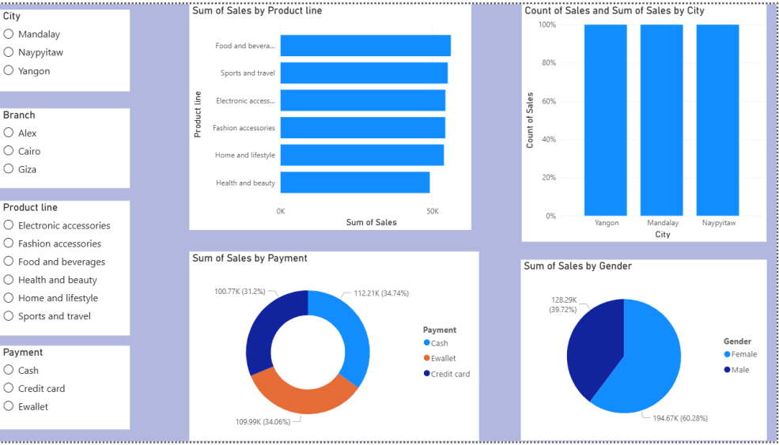

"Dashboard" (images/dashboard.png)

Business Value
This dashboard helps businesses:
- Monitor overall sales performance
- Identify profitable product categories
- Understand customer purchasing behavior
- Make data-driven business decisions
- Improve operational efficiency

Future Enhancements
- Sales Forecasting using Machine Learning
- Customer Segmentation
- Profit Analysis Dashboard
- Real-Time Data Integration
- AI-Powered Sales Prediction

Author
Priyanka Dhakar
Aspiring Data Analyst | SQL | Python | Power BI | Excel

